**DAILY ONLINE ACTIVITIES SUMMARY**

|  |  |  |  |  |  |  |  |  |
| --- | --- | --- | --- | --- | --- | --- | --- | --- |
| **Date:** | **12-07-2020** | | | | | **Name:** | **Anix Jugal D’Cunha** | |
| **Sem & Sec** | **8 sem , A sec** | | | | | **USN:** | **4AL16CS013** | |
| **Online Test Summary** | | | | | | | | |
| **Subject** | | **Not Conducted** | | | | | | |
| **Max. Marks** | | **--** | | **Score** | | | **--** | |
| **Certification Course Summary** | | | | | | | | |
| **Course** | **CSS3 and Bootstrap for Absolute Beginners** | | | | | | | |
| **Certificate Provider** | | | **Udemy** | | **Duration** | | | 3 hours |
| **Coding Challenges** | | | | | | | | |
| **Problem Statement:** Java Program To Calculate Future Investment Value. | | | | | | | | |
| **Status: Competed** | | | | | | | | |
| **Uploaded the report in Github** | | | | | **yes** | | | |
| **If yes Repository name** | | | | | **alvas-education-foundation/dcunhaanixjugal** | | | |
| **Uploaded the report in slack** | | | | | **yes** | | | |

Online Test Details: (Attach the snapshot and briefly write the report for the same)

**Not Conducted**

Certification Course Details: (Attach the snapshot and briefly write the report for the same)

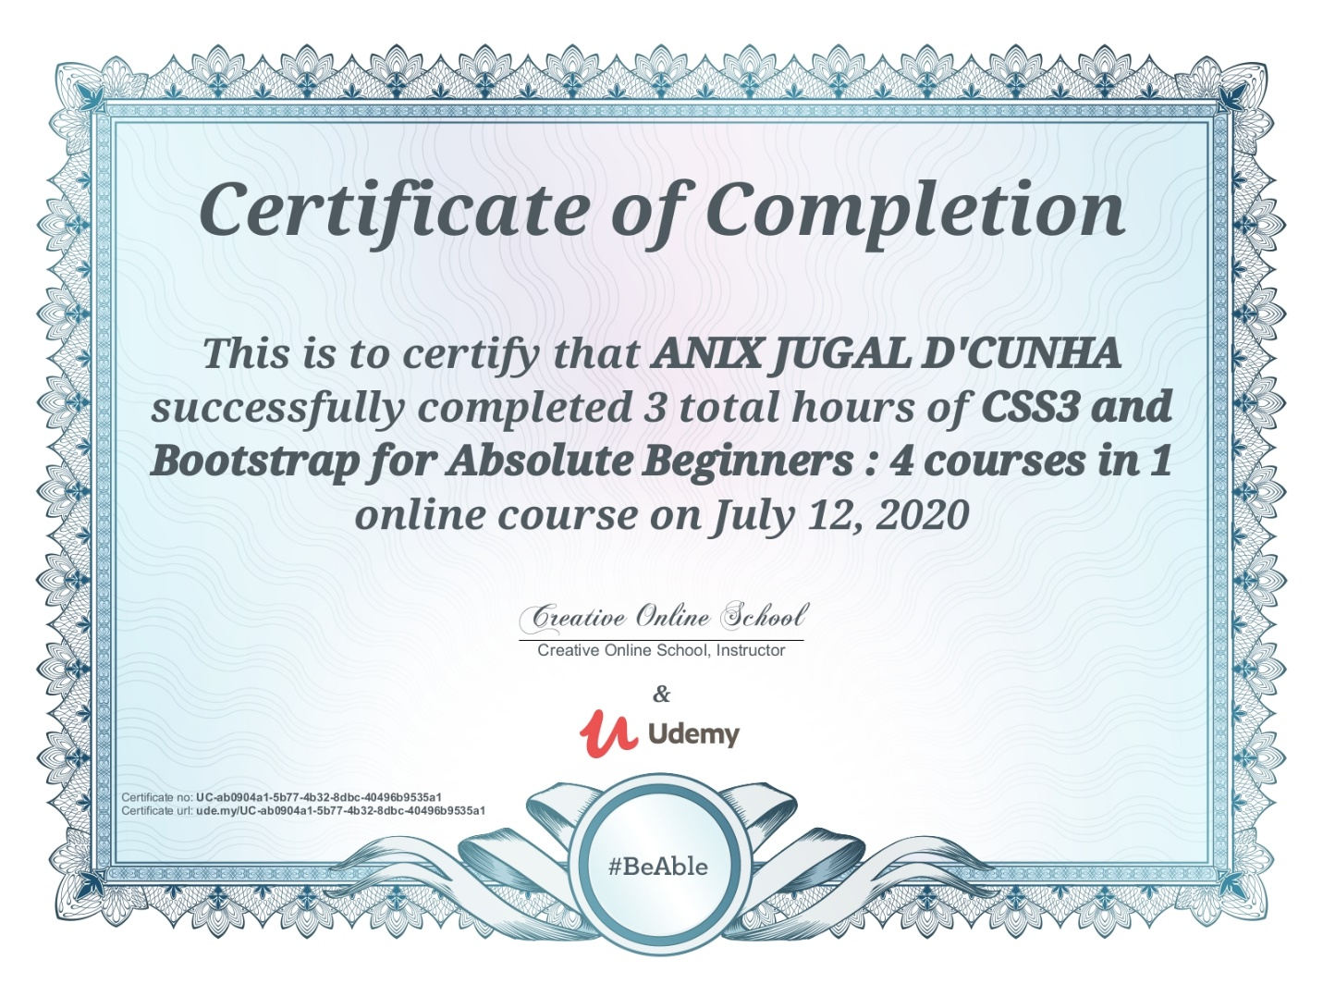

Coding Challenges Details: (Attach the snapshot and briefly write the report for the same)

## Program-> Java Program To Calculate Future Investment Value.

|  |
| --- |
|  |

**import java.util.Scanner;**

**class FIV**

**{**

**public static void main(String args[])**

**{**

**Scanner sc = new Scanner(System.in);**

**System.out.print("Enter present value: ");**

**double p=sc.nextInt();**

**System.out.print("Enter the interest rate: ");**

**double r=sc.nextInt();**

**System.out.print("Enter the time period in years: ");**

**double y=sc.nextInt();**

**double f=p*Math.pow((1+r/100),y);**

**System.out.print("value is: "+f);**

**}**

**}**

**Output:**

**Enter present value: 1000**

**Enter the interest rate: 10**

**Enter the time period in years: 2**

**value is: 1210.0000000000002**

**Enter present value:**

**10000**

**Enter the interest rate: 1**

**Enter the time period in years:**

**10**

**value is: 11046.221254112046**